Oblique Cylindrical Surface

Definition
# Source: AI Source: Provided by: [Data Path: Persons Table -> ID Column: 1, Name_En Column: Motasem Essam] -> From: [ChatGPT] on [7/20/2026]
An Oblique Cylindrical Surface is a cylindrical surface whose generators are not perpendicular to the plane of the base.
For an oblique circular cylindrical surface, the directrix is a circle, while the generators are parallel to one another and are inclined relative to the perpendicular direction of the base.
Unlike a right circular cylindrical surface, the axis is not perpendicular to the base.
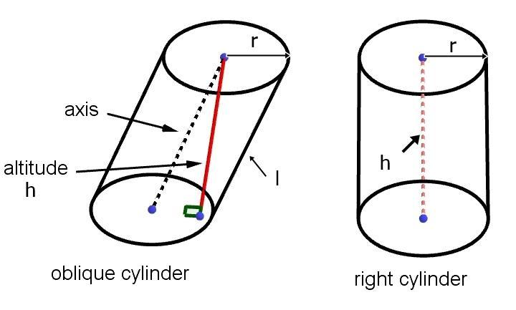
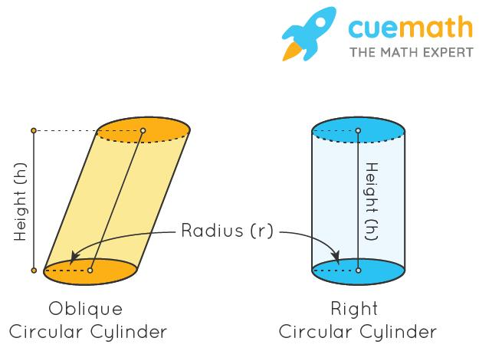
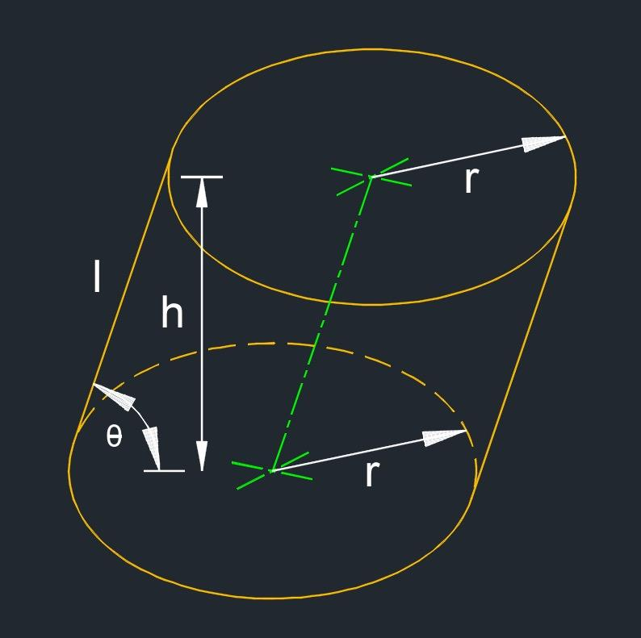
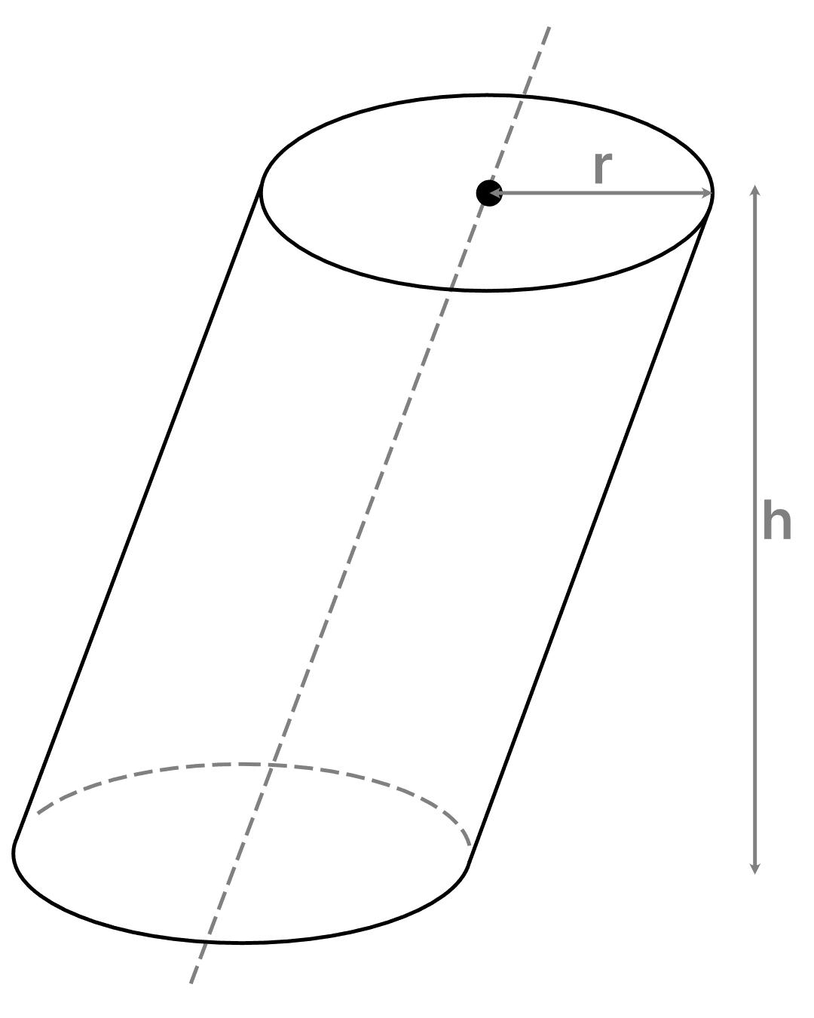
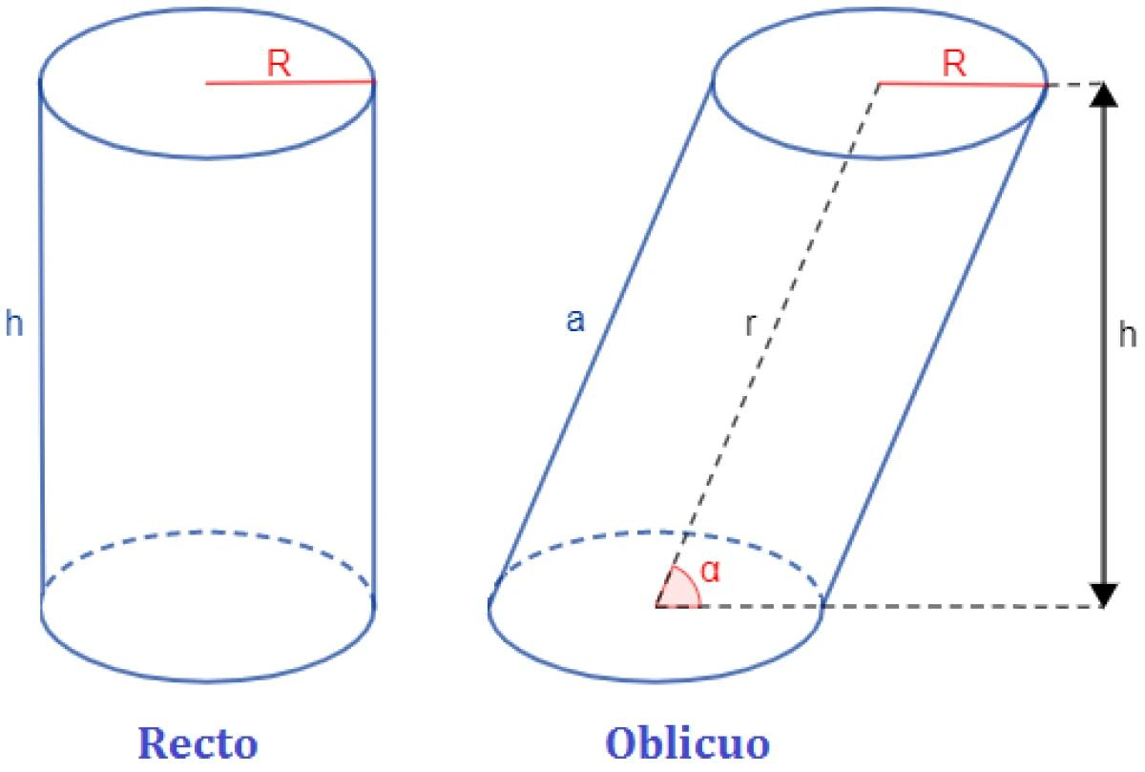

Purpose
# Source: AI Source: Provided by: [Data Path: Persons Table -> ID Column: 1, Name_En Column: Motasem Essam] -> From: [ChatGPT] on [7/20/2026]
An oblique cylindrical surface is used to:
- Describe inclined cylindrical surfaces.
- Study cylinders whose axes are not perpendicular to their bases.
- Model slanted cylindrical structures.
- Distinguish oblique cylinders from right cylinders.
- Study the relationship between generators, axis, bases, and height.
- Extend the concept of cylindrical surfaces beyond the right-cylinder case.

Fundamental Elements
# Source: AI Source: Provided by: [Data Path: Persons Table -> ID Column: 1, Name_En Column: Motasem Essam] -> From: [ChatGPT] on [7/20/2026]
For an oblique circular cylindrical surface, the main elements are:

1. Circular Directrix
# Source: AI Source: Provided by: [Data Path: Persons Table -> ID Column: 1, Name_En Column: Motasem Essam] -> From: [ChatGPT] on [7/20/2026]
The directrix is a circle that determines the shape of the cylindrical cross-section.
Its radius is:
$$\boxed{r}$$

2. Generators
# Source: AI Source: Provided by: [Data Path: Persons Table -> ID Column: 1, Name_En Column: Motasem Essam] -> From: [ChatGPT] on [7/20/2026]
The generators are straight lines that form the cylindrical surface.
They are:
$$\boxed{\text{parallel to one another}}$$
but they are not perpendicular to the base.

3. Axis
# Source: AI Source: Provided by: [Data Path: Persons Table -> ID Column: 1, Name_En Column: Motasem Essam] -> From: [ChatGPT] on [7/20/2026]
The axis is the line joining the centers of the circular bases.
For an oblique cylinder:
$$\boxed{\text{Axis}⊥̸\text{Base}}$$

4. Height
# Source: AI Source: Provided by: [Data Path: Persons Table -> ID Column: 1, Name_En Column: Motasem Essam] -> From: [ChatGPT] on [7/20/2026]
The height $h$is the perpendicular distance between the two parallel base planes.
This is important: the height is not the length of the slanted generator.

5. Slant Length
# Source: AI Source: Provided by: [Data Path: Persons Table -> ID Column: 1, Name_En Column: Motasem Essam] -> From: [ChatGPT] on [7/20/2026]
The distance along a generator between the two base planes is sometimes called the generator length or lateral edge length.
Let this length be $s$.
For an oblique cylinder:
$$\boxed{s≠h}$$
in general.

Geometric Configuration
# Source: AI Source: Provided by: [Data Path: Persons Table -> ID Column: 1, Name_En Column: Motasem Essam] -> From: [ChatGPT] on [7/20/2026]
In an oblique cylindrical surface, the upper circular base is displaced sideways relative to the lower circular base.
The generators remain parallel, but they are inclined.
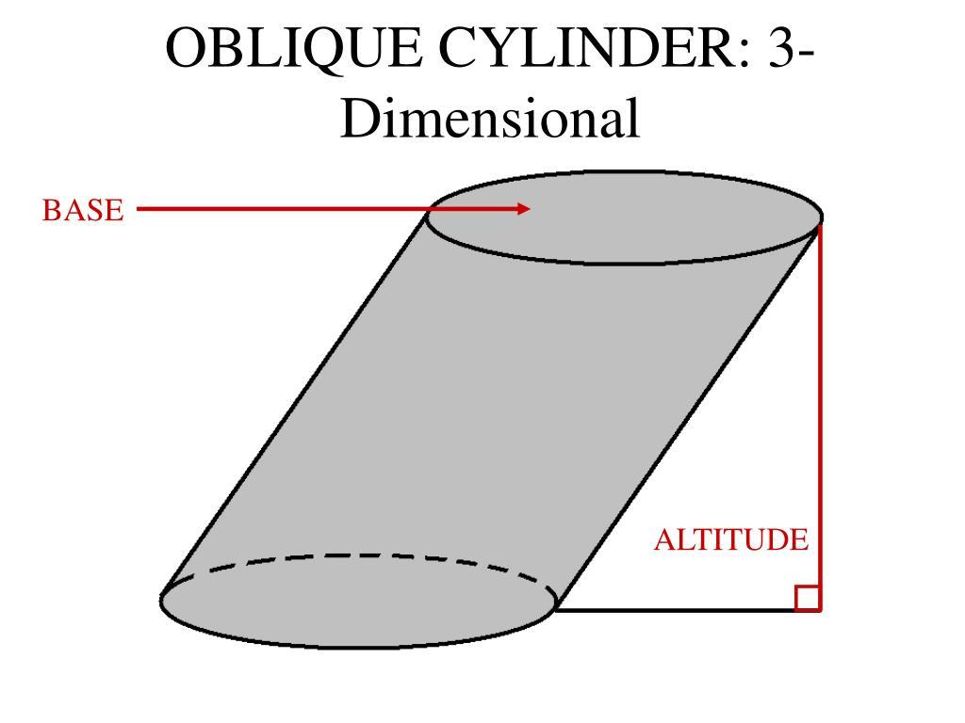
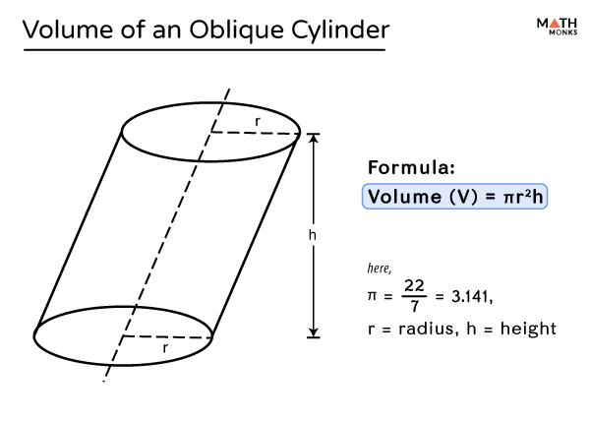
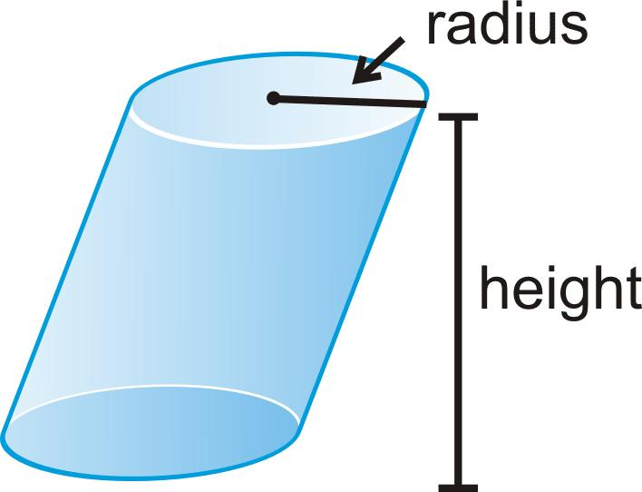
The essential distinction is:
Right Circular Cylinder
$$\text{Generator}⊥\text{Base}$$
Oblique Circular Cylinder
$$\text{Generator}⊥̸\text{Base}$$
Both still have parallel generators.

Mathematical Representation
# Source: AI Source: Provided by: [Data Path: Persons Table -> ID Column: 1, Name_En Column: Motasem Essam] -> From: [ChatGPT] on [7/20/2026]
A general oblique circular cylindrical surface can be represented as a translated circle.
Suppose the lower circular directrix lies in the plane $z=0$:
$$x^{2}+y^{2}=r^{2}$$
If the circle is translated by a horizontal displacement as it moves upward, the resulting surface is oblique.
For example, if the displacement in the $x$-direction is proportional to $z$:
$$x-\frac{d}{h}z$$
then one possible equation is:
$$\boxed{{\left(x-\frac{d}{h}z\right)}^{2}+y^{2}=r^{2}}$$
for:
$$0≤z≤h$$
where:
- $r$= radius
- $h$= perpendicular height
- $d$= horizontal displacement between corresponding centers of the bases.
This equation describes an oblique circular cylindrical surface whose axis is inclined relative to the $z$-axis.

Parametric Representation
# Source: AI Source: Provided by: [Data Path: Persons Table -> ID Column: 1, Name_En Column: Motasem Essam] -> From: [ChatGPT] on [7/20/2026]
An oblique circular cylindrical surface can be represented parametrically as:
$$x=r\cos{θ}+\frac{d}{h}t \\ y=r\sin{θ} \\ z=t$$
where:
$$0≤θ<2π$$
and:
$$0≤t≤h$$
Here:
- $θ$moves around the circular cross-section.
- $t$moves along the height.
- $d$represents the horizontal displacement of the upper base.
The generator direction is therefore:
$$\boxed{\vec{v}=\left(\frac{d}{h} , 0 , 1\right)}$$
rather than simply:
$$\left(0 , 0 , 1\right)$$
as in the standard right-cylinder orientation.

Surface Area
# Source: AI Source: Provided by: [Data Path: Persons Table -> ID Column: 1, Name_En Column: Motasem Essam] -> From: [ChatGPT] on [7/20/2026]
For an oblique circular cylinder, the curved surface area is not generally given by simply replacing the height in
$$2πrh$$
with the slant generator length.
For a simple oblique circular cylinder, the lateral surface can be developed into a parallelogram-like region, rather than the rectangle obtained from a right circular cylinder.
However, there is an important result:
$$\boxed{CSA=2πrh}$$
when $h$is the perpendicular distance between the parallel bases and the cylinder is a standard circular cylinder.
Thus, the lateral surface area depends on the base circumference and the perpendicular separation of the bases.
The total surface area is:
$$\boxed{TSA=2πrh+2πr^{2}}$$

Important Distinction: Height vs Generator Length
# Source: AI Source: Provided by: [Data Path: Persons Table -> ID Column: 1, Name_En Column: Motasem Essam] -> From: [ChatGPT] on [7/20/2026]
This is one of the most important features of an oblique cylinder.
For a right circular cylinder:
$$\boxed{s=h}$$
But for an oblique cylinder:
$$\boxed{s>h}$$
where:
- $s$= length of a generator between the bases
- $h$= perpendicular height
If the horizontal displacement between the centers of the bases is $d$, then in the simplest displacement geometry:
$$\boxed{s=\sqrt{h^{2}+d^{2}}}$$
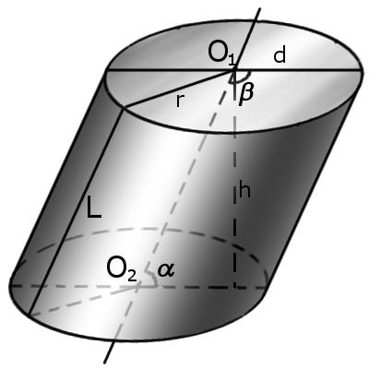

Main Properties
# Source: AI Source: Provided by: [Data Path: Persons Table -> ID Column: 1, Name_En Column: Motasem Essam] -> From: [ChatGPT] on [7/20/2026]
An oblique cylindrical surface has the following properties:
- It is a curved surface.
- Its generators are straight lines.
- Its generators are parallel to one another.
- The generators are not perpendicular to the base.
- The axis is not perpendicular to the base.
- Its bases are parallel.
- An oblique circular cylinder has circular bases.
- The perpendicular distance between the bases is the height $h$.
- The generator length is generally greater than the height.
- It has no vertices.
- The lateral surface has no sharp edges.
- A finite lateral surface has two circular boundary curves.
- Its lateral surface is an open surface.
- Adding the two circular bases produces a closed surface.

Examples

Example 1: Identifying an Oblique Cylinder
# Source: AI Source: Provided by: [Data Path: Persons Table -> ID Column: 1, Name_En Column: Motasem Essam] -> From: [ChatGPT] on [7/20/2026]
Suppose a cylindrical surface has:
- Circular bases
- Parallel generators
- Generators inclined at ${30}^{∘}$to the perpendicular direction of the bases
Because the generators are not perpendicular to the bases, it is:
$$\boxed{\text{Oblique Circular Cylindrical Surface}}$$

Example 2: Finding the Generator Length
# Source: AI Source: Provided by: [Data Path: Persons Table -> ID Column: 1, Name_En Column: Motasem Essam] -> From: [ChatGPT] on [7/20/2026]
Suppose:
$$h=12\text{ cm}$$
and the horizontal displacement between the centers of the bases is:
$$d=5\text{ cm}$$
Then:
$$s=\sqrt{h^{2}+d^{2}} \\ s=\sqrt{{12}^{2}+5^{2}} \\ s=\sqrt{144+25} \\ s=\sqrt{169}$$
Therefore:
$$\boxed{s=13\text{ cm}}$$
So the generator is $13$cm long, while the perpendicular height is only $12$cm.

Example 3: Finding Curved Surface Area
# Source: AI Source: Provided by: [Data Path: Persons Table -> ID Column: 1, Name_En Column: Motasem Essam] -> From: [ChatGPT] on [7/20/2026]
Suppose an oblique circular cylinder has:
$$r=4\text{ cm}$$
and perpendicular height:
$$h=10\text{ cm}$$
Then:
$$CSA=2πrh \\ CSA=2π\left(4\right)\left(10\right) \\ \boxed{CSA=80π{\text{ cm}}^{2}}$$
Approximately:
$$\boxed{CSA≈251.33{\text{ cm}}^{2}}$$

Oblique Cylindrical Surface vs Right Circular Cylindrical Surface
# Source: AI Source: Provided by: [Data Path: Persons Table -> ID Column: 1, Name_En Column: Motasem Essam] -> From: [ChatGPT] on [7/20/2026]
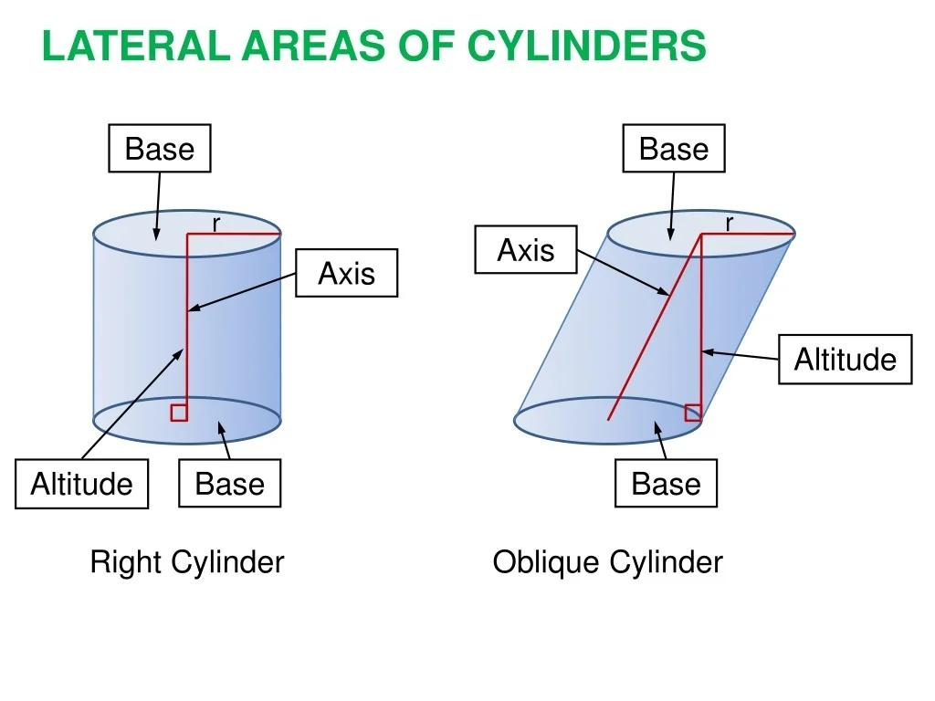
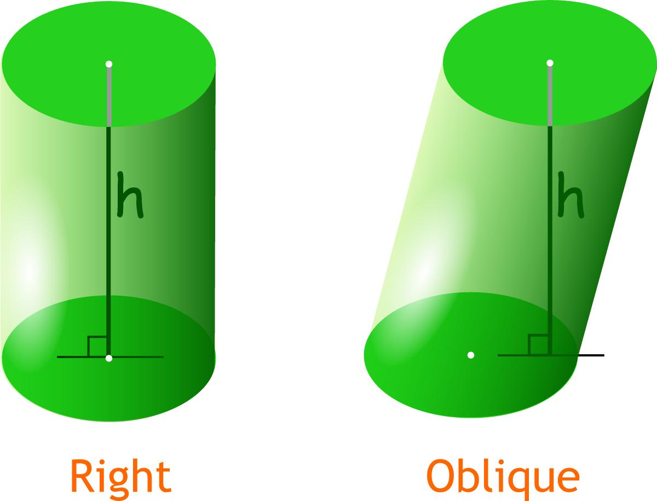
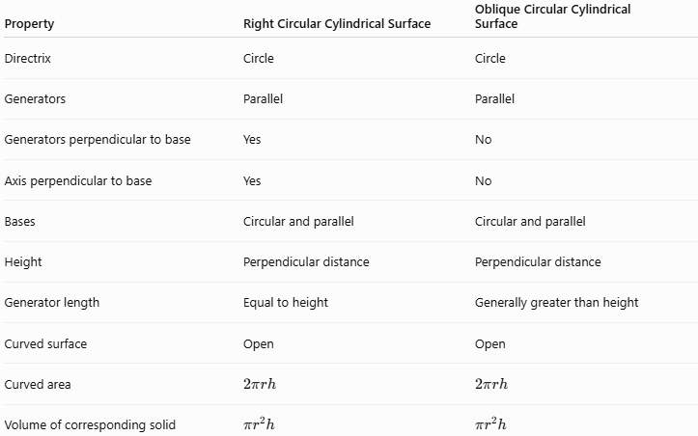
Property | Right Circular Cylindrical Surface | Oblique Circular Cylindrical Surface
Directrix | Circle | Circle
Generators | Parallel | Parallel
Generators perpendicular to base | Yes | No
Axis perpendicular to base | Yes | No
Bases | Circular and parallel | Circular and parallel
Height | Perpendicular distance | Perpendicular distance
Generator length | Equal to height | Generally greater than height
Curved surface | Open | Open
Curved area | $$2πrh$$ | $$2πrh$$
Volume of corresponding solid | $$πr^{2}h$$ | $$πr^{2}h$$
An important result is that, for cylinders with the same base area and perpendicular height:
$$\boxed{\text{Right and Oblique Cylinders have the same volume}}$$
and their lateral area is also determined by the corresponding perpendicular height in the standard circular case.

Relationship with Circular Cylindrical Surface
# Source: AI Source: Provided by: [Data Path: Persons Table -> ID Column: 1, Name_En Column: Motasem Essam] -> From: [ChatGPT] on [7/20/2026]
The classification is:
$$\boxed{\text{Cylindrical Surface}→\text{Circular Cylindrical Surface}→\left\{\begin{matrix}\text{Right Circular Cylindrical Surface} \\ \text{Oblique Circular Cylindrical Surface}\end{matrix}\right.}$$
The word circular tells us about the directrix.
The word oblique tells us about the orientation.
Therefore:
- Circular → circular directrix
- Oblique → generators not perpendicular to the base

Relationship with Conical Surface
# Source: AI Source: Provided by: [Data Path: Persons Table -> ID Column: 1, Name_En Column: Motasem Essam] -> From: [ChatGPT] on [7/20/2026]
An oblique cylindrical surface and an oblique conical surface may look somewhat similar, but their generators behave differently.
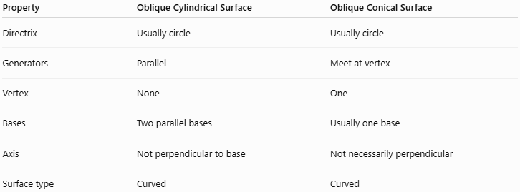
Property | Oblique Cylindrical Surface | Oblique Conical Surface
Directrix | Usually circle | Usually circle
Generators | Parallel | Meet at vertex
Vertex | None | One
Bases | Two parallel bases | Usually one base
Axis | Not perpendicular to base | Not necessarily perpendicular
Surface type | Curved | Curved
The defining distinction remains:
$$\boxed{\text{Cylinder: generators are parallel}} \\ \boxed{\text{Cone: generators meet at a vertex}}$$

Real-World Applications
# Source: AI Source: Provided by: [Data Path: Persons Table -> ID Column: 1, Name_En Column: Motasem Essam] -> From: [ChatGPT] on [7/20/2026]
Oblique cylindrical surfaces can model:
- Inclined pipes
- Slanted tubes
- Angled ducts
- Certain architectural columns
- Inclined tanks
- Offset cylindrical components
- Some industrial piping systems
- Specialized mechanical structures
They are particularly useful when a cylindrical structure must connect two locations that are not directly aligned perpendicular to the base.

Advantages
# Source: AI Source: Provided by: [Data Path: Persons Table -> ID Column: 1, Name_En Column: Motasem Essam] -> From: [ChatGPT] on [7/20/2026]
- Models inclined cylindrical structures accurately.
- Extends cylindrical geometry beyond the right-cylinder case.
- Maintains parallel generators.
- Retains circular cross-sections for the circular case.
- Useful in engineering and architectural design.
- Demonstrates the distinction between perpendicular height and slanted generator length.

Limitations
# Source: AI Source: Provided by: [Data Path: Persons Table -> ID Column: 1, Name_En Column: Motasem Essam] -> From: [ChatGPT] on [7/20/2026]
- Its geometry is less visually simple than a right circular cylinder.
- The generators are not equal to the perpendicular height.
- Coordinate equations can be more complicated depending on the orientation.
- The surface development is more complicated than the simple rectangle of a right circular cylinder.
- Care is required to distinguish height from generator length.

Key Points
# Source: AI Source: Provided by: [Data Path: Persons Table -> ID Column: 1, Name_En Column: Motasem Essam] -> From: [ChatGPT] on [7/20/2026]
- An Oblique Cylindrical Surface has generators that are parallel but not perpendicular to the base.
- An oblique circular cylindrical surface has a circular directrix.
- Its axis is not perpendicular to the base.
- Its height $h$is the perpendicular distance between the bases.
- The generator length $s$is generally greater than $h$.
- In the simple displacement configuration:
$$\boxed{s=\sqrt{h^{2}+d^{2}}}$$
- The corresponding circular cylinder has volume:
$$\boxed{V=πr^{2}h}$$
- The lateral surface is open.
- Adding the two bases creates a closed surface.
- The main difference from a right circular cylindrical surface is orientation:
$$\boxed{\text{Right: Generator}⊥\text{Base}} \\ \boxed{\text{Oblique: Generator}⊥̸\text{Base}}$$

Conclusion
# Source: AI Source: Provided by: [Data Path: Persons Table -> ID Column: 1, Name_En Column: Motasem Essam] -> From: [ChatGPT] on [7/20/2026]
An Oblique Cylindrical Surface is a cylindrical surface in which the generators remain parallel to one another but are inclined relative to the perpendicular direction of the base. When its directrix is a circle, it is specifically an Oblique Circular Cylindrical Surface.
The most important geometric distinction is between the perpendicular height $h$and the generator length $s$:
$$\boxed{s>h}$$
for a genuinely oblique cylinder.
For your taxonomy, the most precise organization is:
$$\boxed{\text{Surface}→\text{Curved Surface}→\text{Cylindrical Surface}→\text{Circular Cylindrical Surface}→\text{Oblique Circular Cylindrical Surface}}$$
This makes Right Circular Cylindrical Surface and Oblique Circular Cylindrical Surface parallel subtypes of Circular Cylindrical Surface.

